**IBM- Descriptive Analysis Project**

**(Admission and Placement analysis)**

A project by:

Sarvesh Navare (60004180096)

Nidhi Panchal (60013180013)

Pugazharasan Valarmathi (60001190040)

**Introduction:**

Keeping a track of student performance is very important for colleges. This analysis includes the students’ data of DJSCE from 2017 to 2020. The data includes students’ merit marks, previous examination marks, the academic results of every semester, final placement companies along with CTC and post- graduate program data, collected in a tabular format and analysed using TABLEAU software.

The purpose of the analysis is to gain insight of the students’ potential to get a desired placement CTC or a post-graduate program. By keeping track of a students’ performance from the time they entered college to the time they left the college, this analysis helps in digging out recent trends in student behavior and how it affects their results academically.

**Visualisations:**

1. **Year-on-Year Entry Analysis (Electronics Passout 2021-2024)**

The entry data of Electronics passout batch 2021-2024 is taken for analysis. The data includes the Merit Marks, Merit Number, Application ID, Candidate Name, Gender, Eligibility %, Seat Type and Cap Round.

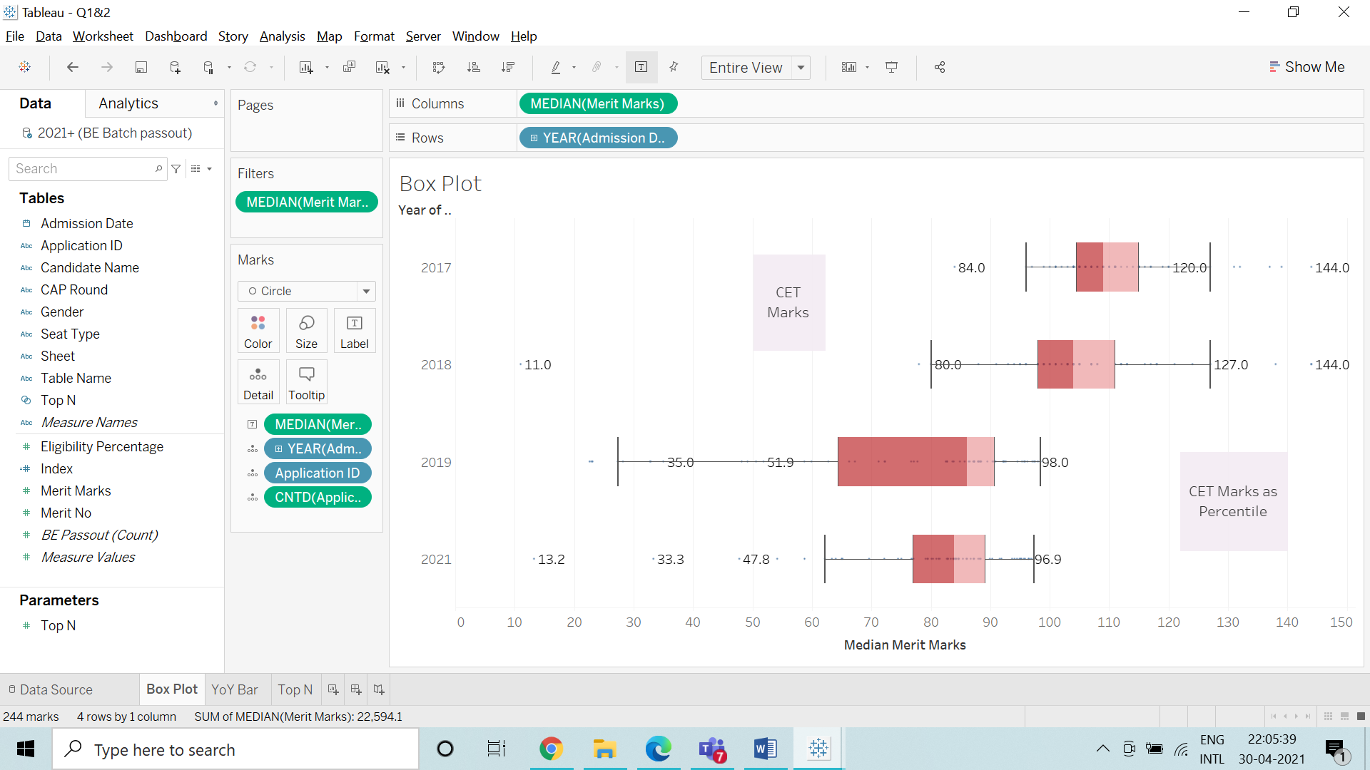

Median of Merit Marks for each Admission Date Year. The marks are labeled by median of Merit Marks for the Year 2017 and 2018. The marks are labeled as Percentile of Merit Marks for the Year 2019 and 2021. Details are shown for Admission Date Year and Application ID. The view is filtered on median of Merit Marks, which ranges from 11.0 to 144.0. A Box Plot is used to show the trend in the Merit Marks of the students’.

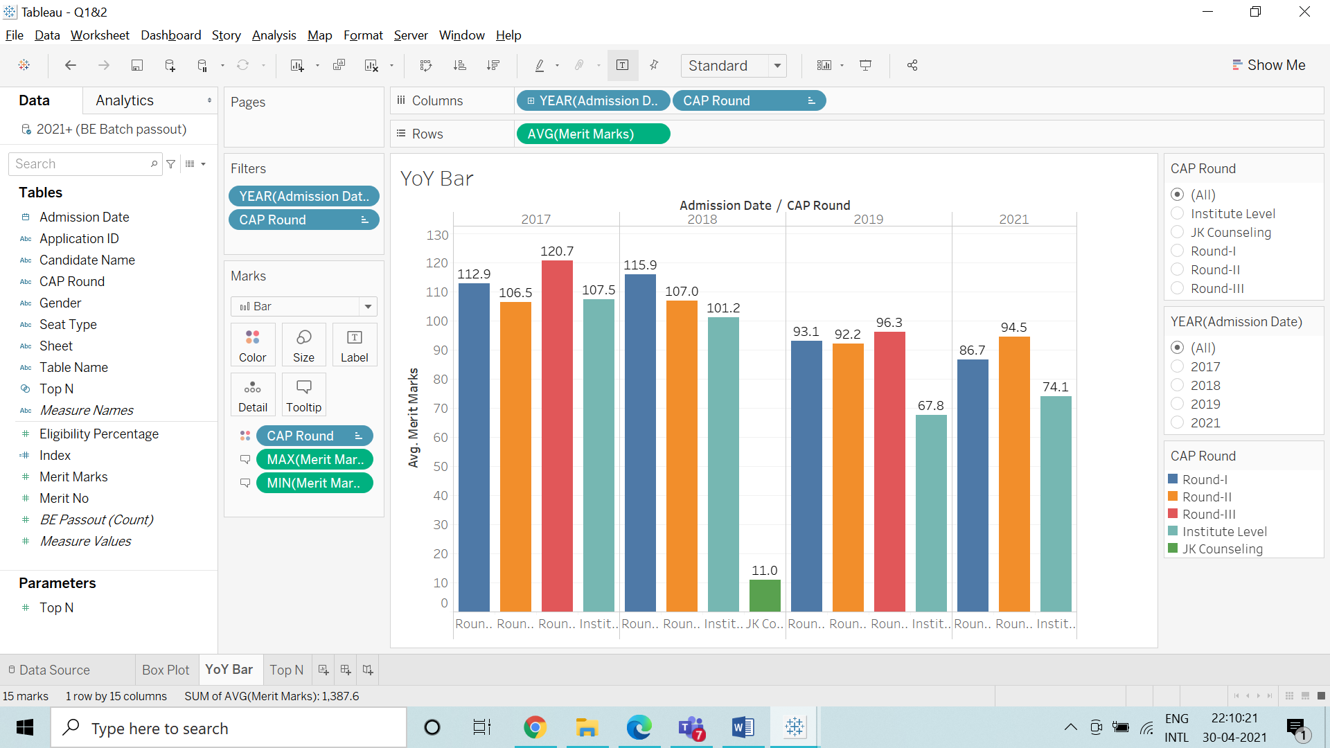

Average of Merit Marks for each CAP Round broken down by Admission Date Year (Percentile for Year 2019 and 2021). Color shows details about CAP Round. The view is filtered on Admission Date Year and CAP Round. The Admission Date Year filter keeps 2017, 2018, 2019 and 2021. The CAP Round filter keeps Institute Level, JK Counseling, Round-I, Round-II and Round-III. A Year-on-Year Bar Chart of each Cap Round is obtained.

1. **Top N students Based on Merit Marks**

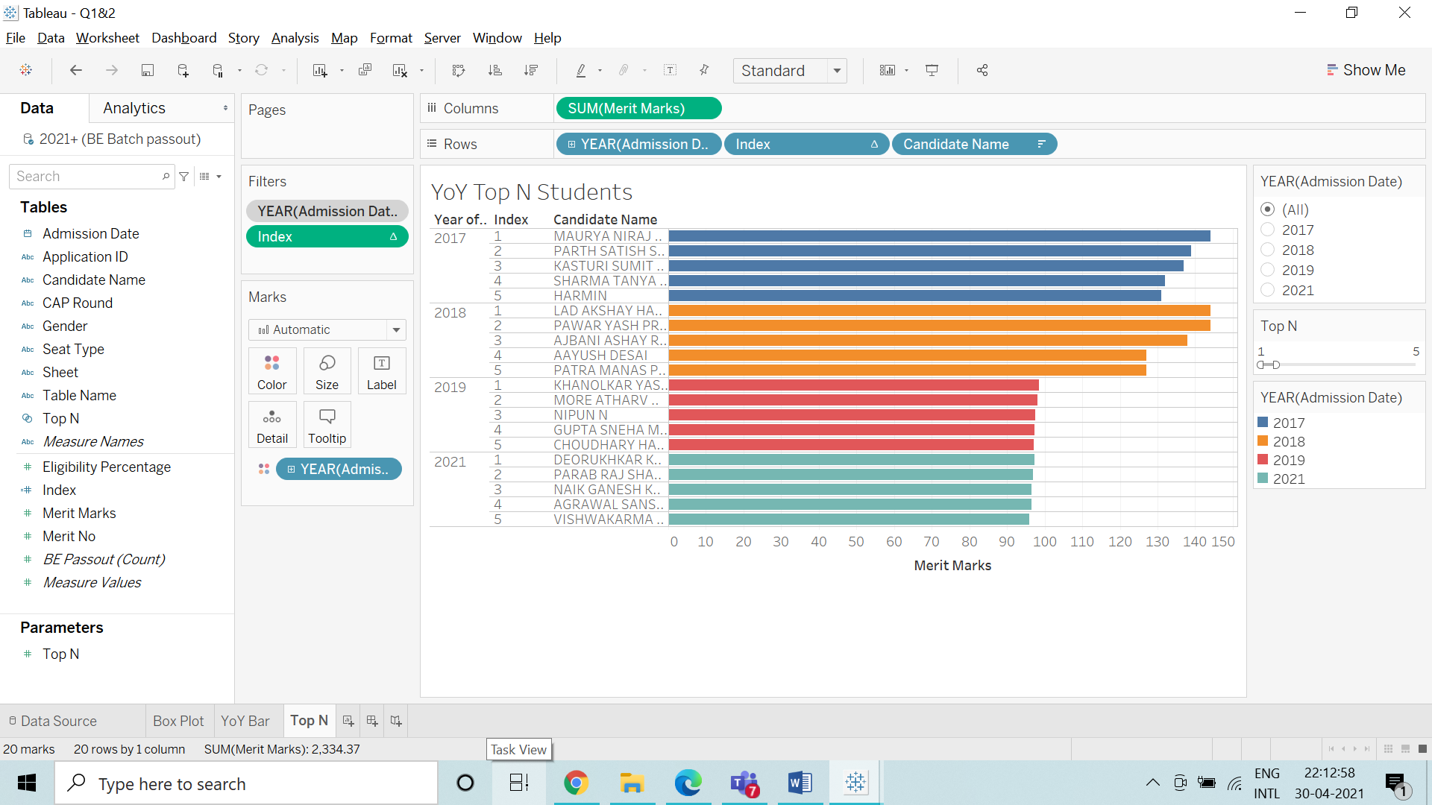

Sum of Merit Marks (Percentile Merit Marks for Year 2019 and 2021) for each Index broken down by Admission Date Year and Candidate Name. Color shows details about Admission Date Year. The context is filtered on Admission Date Year, which keeps 2017, 2018, 2019 and 2021. The data is filtered on Index, which ranges from 1 to 5. A horizontal Bar Graph is obtained for Top N students of each year based on their Merit Marks.

1. **Entry, Result, AMCAT Score, Placement & Higher Studies for Electronics Batch of 2021**

A left join was created between the Result and Entry, AMCAT Score, Placement & Higher Studies for Electronics Batch of 2021. The important fields from these sheets include SAP ID, Candidate Name, Merit Marks, Cap Round, Academic Grades, AMCAT Scores, Company, CTC and Post-Graduate Program.

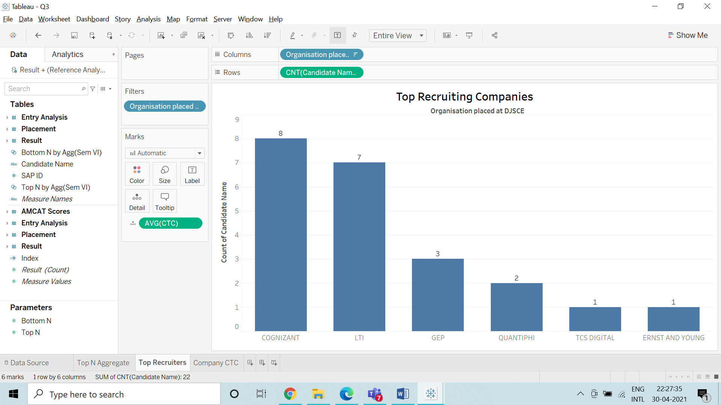

Count of Candidate Name for each Organisation placed at DJSCE. The view is filtered on Organisation placed at DJSCE. A Bar Chart is obtained which shows the Top Companies based on the number of recruitments from Electronics batch 2021.

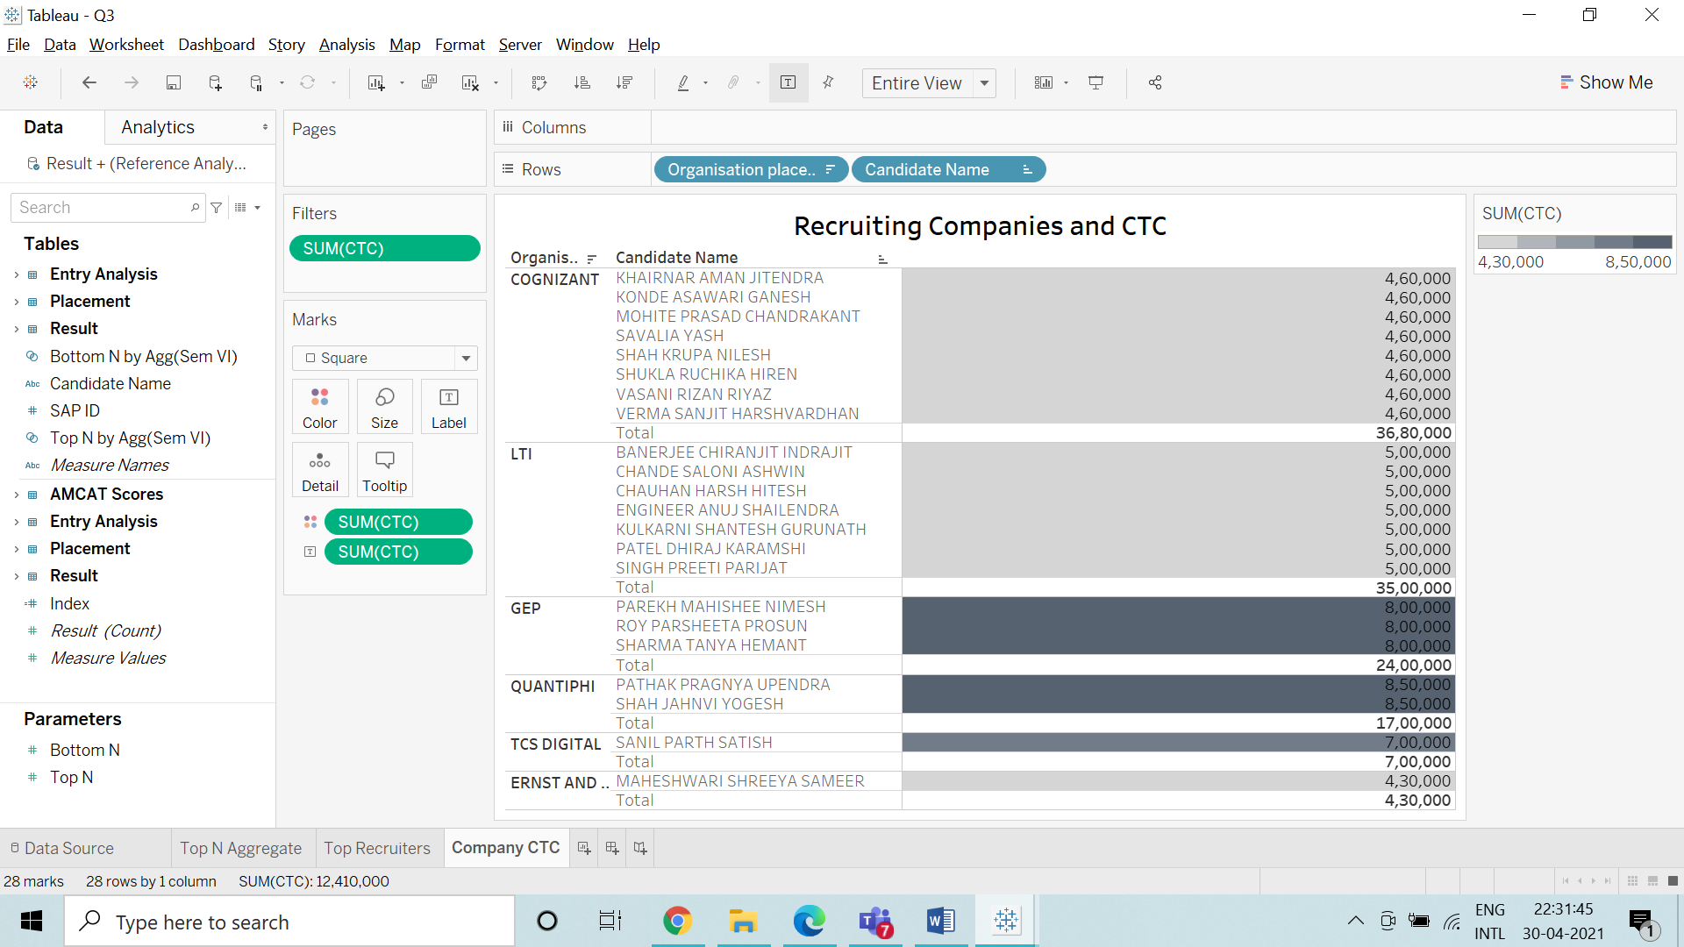

Sum of CTC broken down by Organisation placed at DJSCE and Candidate Name. Color shows sum of CTC. The marks are labeled by the sum of CTC. The view is filtered on the sum of CTC. This visualisation gives an understanding of the company if it's a mass recruiting company and how much CTC is the company ready to offer DJSCE students.

1. **Full analysis 2018**

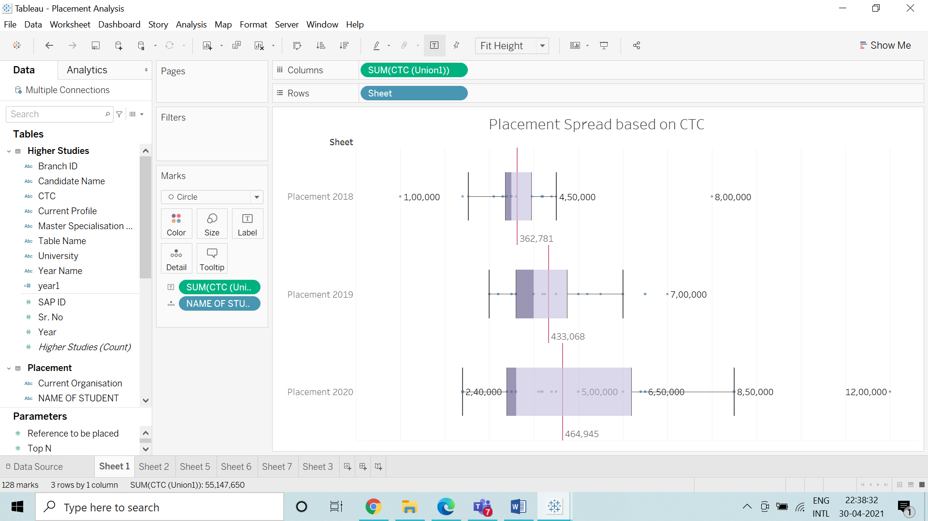

Sum of CTC for each Year. The marks are labeled by sum of CTC. The maximum, Minimum and Average CTC obtained by students’ of the year 2018,2019 and 2020 is shown along with the outliers.

1. **Placement Analysis of Electronics Batch 2018-2020**

The Placement and Higher Studies data is used in the analysis. The data includes, the SAP ID, Candidate Name, Organisation Placed at DJSCE, Current Organisation and CTC Packages and Post-graduate program of the Candidate.

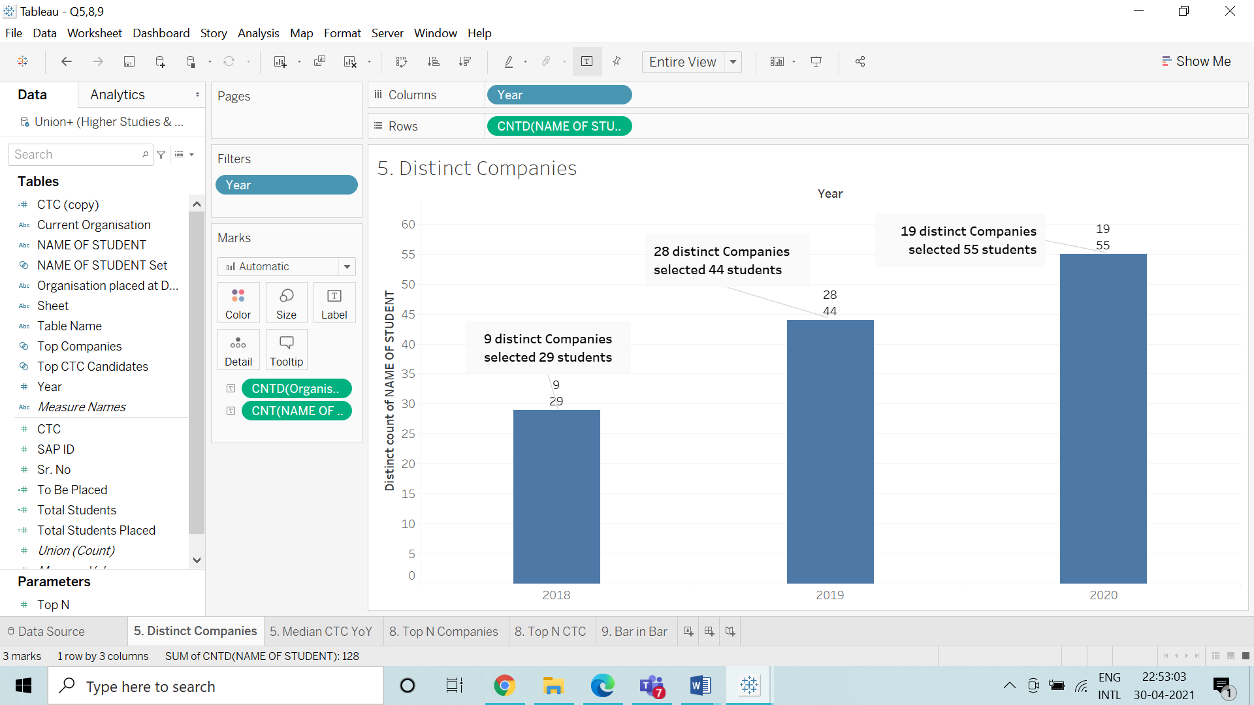

Distinct count of Student for each Year. The marks are labeled by distinct count of Organisation placed at DJSCE and count of Students. The view is filtered on Year, which keeps 2018, 2019 and 2020. A Bar Chart is used to determine the increase in distinct companies and the number of students selected by those companies on a Year-on-Year basis. The findings are mentioned in the Annotations.

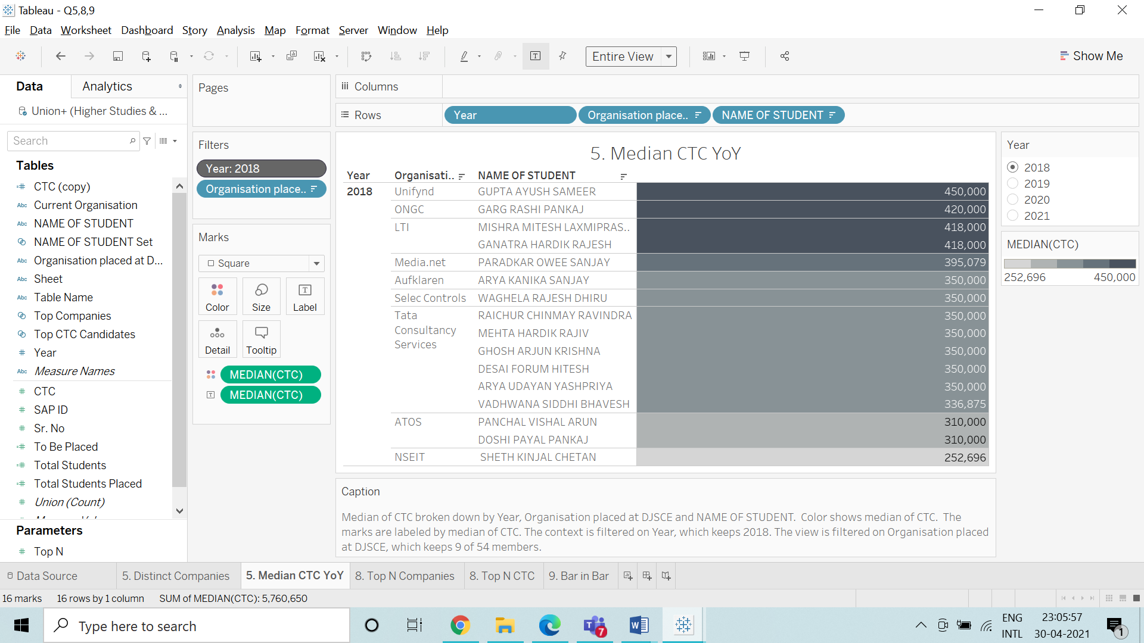

Median of CTC broken down by Year, Organisation placed at DJSCE and NAME OF STUDENT. Color shows median of CTC. The marks are labeled by median of CTC. The context is filtered on Year. The view is filtered on Organisation placed at DJSCE, which keeps 6 of 54 members. The Median CTC is obtained for each company along with the Name of Student in a tabular format.

1. **Placement Data Before and After Pandemic**

The same Placement data of Electronics Batch 2018-2020 is used. The placement data for 2021 (the year of the pandemic) was added to that data.

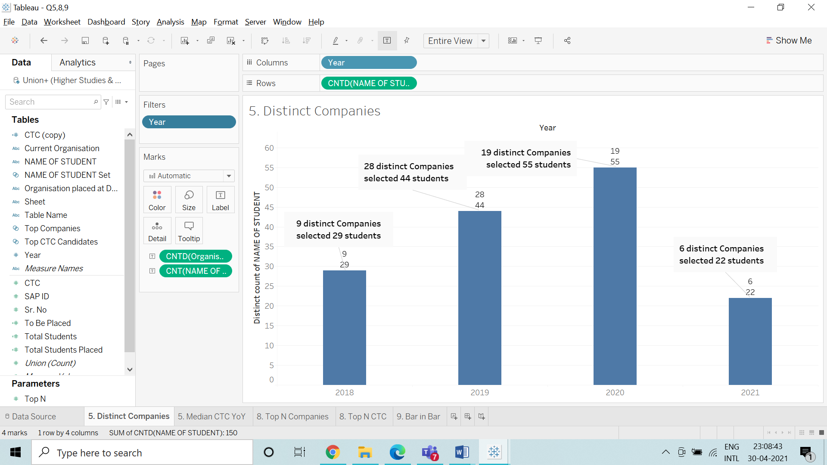

Distinct count of Students for each Year. The marks are labeled by distinct count of Organisation placed at DJSCE and count of Students. The view is filtered on Year, which keeps 2018, 2019, 2020 and 2021. In the obtained Bar Graph it is seen that the Distinct companies who picked up the Electronics students have dropped to a considerable number. The data for 2021 was not complete due to the pandemic crisis as a lot of students’ placement procedure was unable to complete. So no final conclusions can be drawn in comparison with the before and after pandemic situation.

**8. Top 5 Companies and Top 5 CTC Packages (2018-2020)**

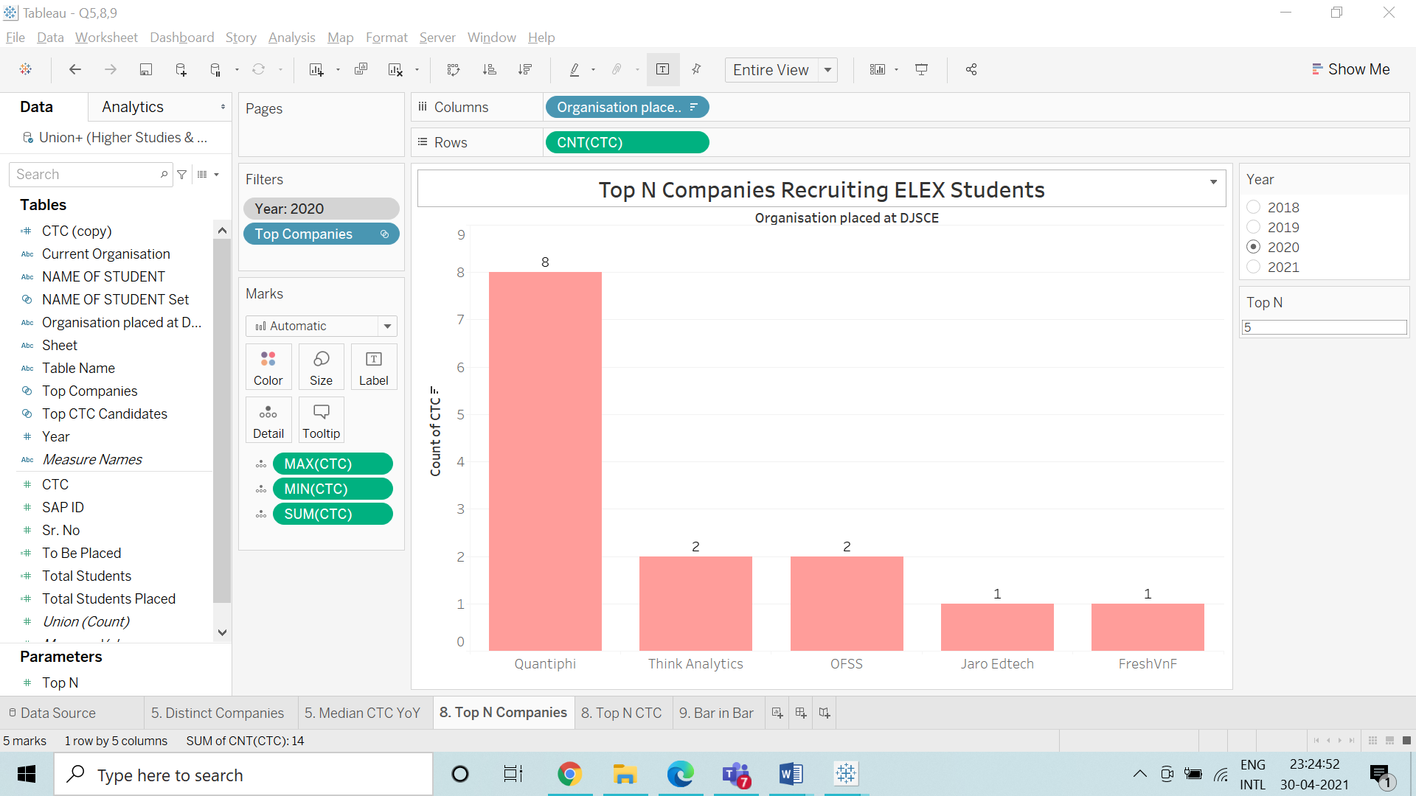

Count of CTC for each Organisation placed at DJSCE. The context is filtered on Year, which keeps 2020. The data is filtered on Top Companies, which keeps 5 members.

A parameter is used to indicate the Top 5 Companies

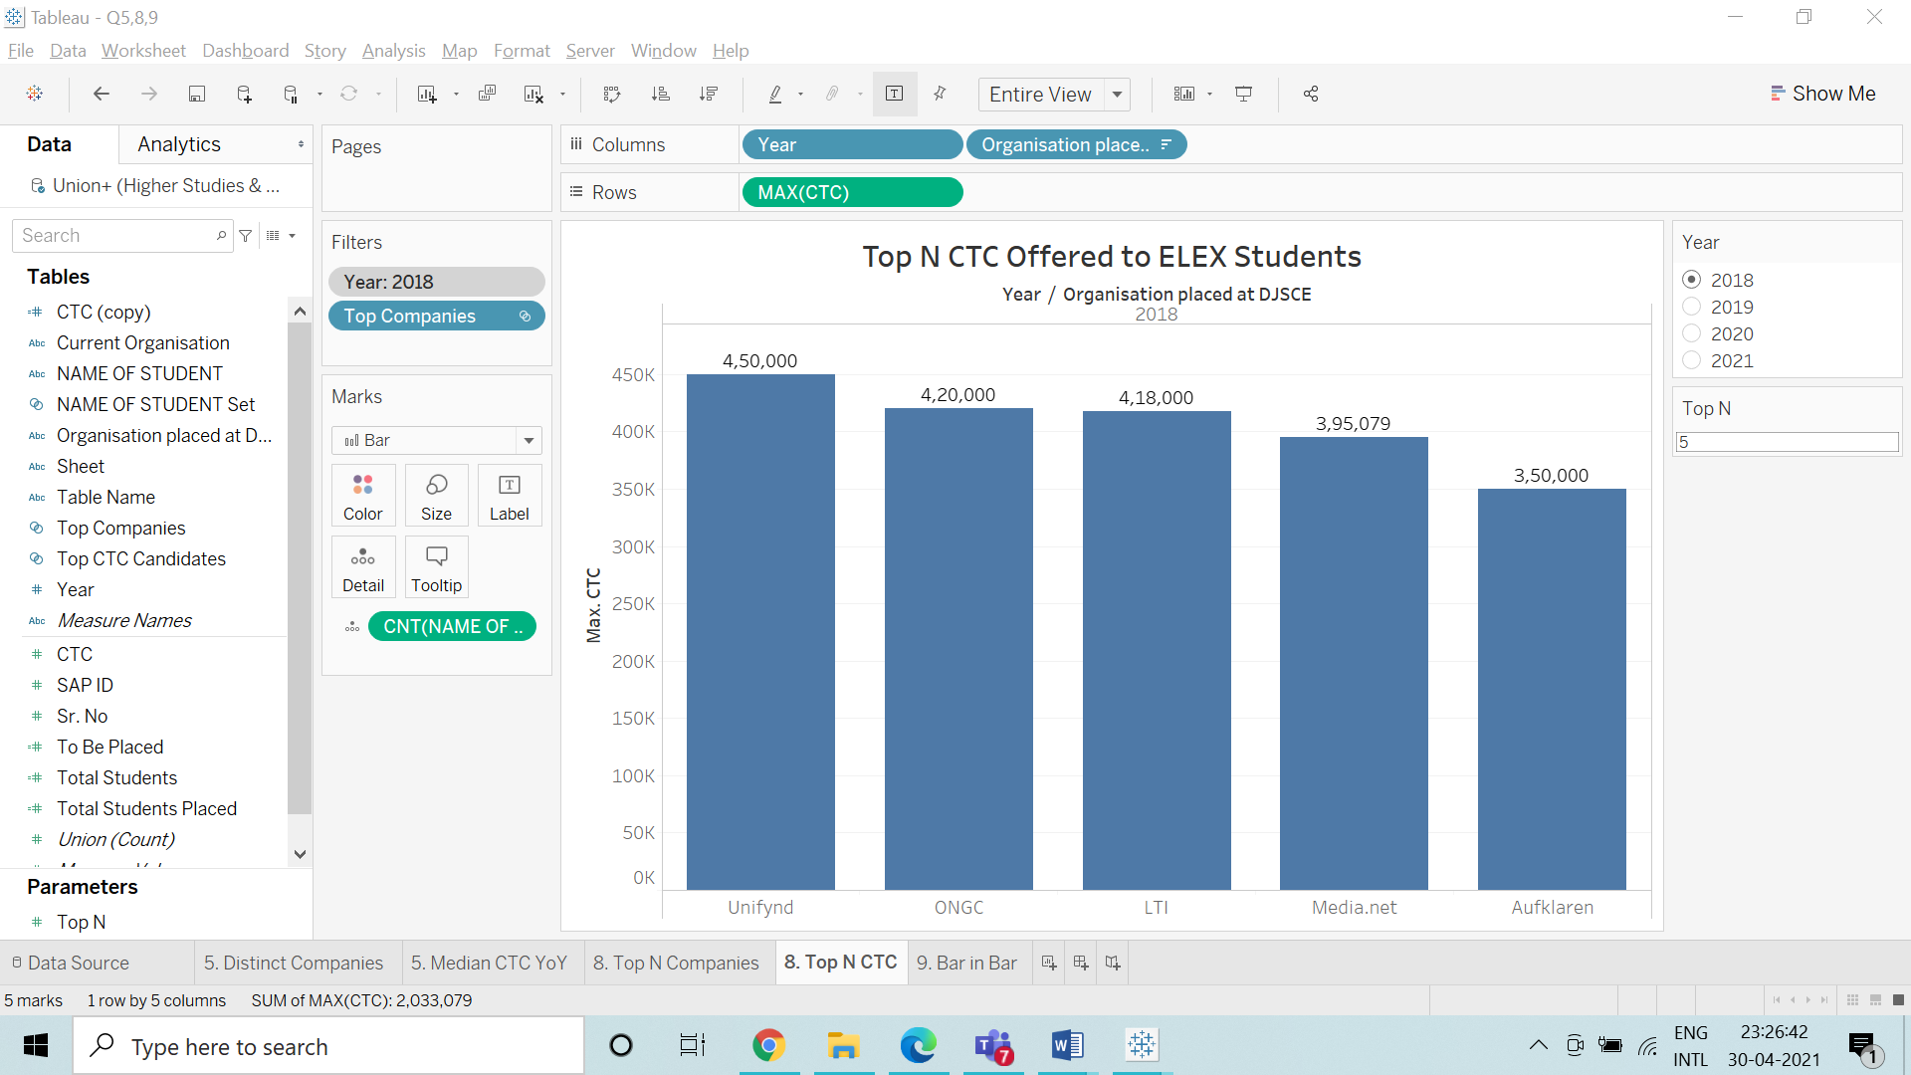

Maximum of CTC for each Organisation placed at DJSCE broken down by Year. The context is filtered on Year, which keeps 2018. The data is filtered on Top Companies, which keeps 5 members. A parameter is used to indicate the Top 5 CTC Packages.

**9. Total Count of Students Placed vs Total To Be Placed**

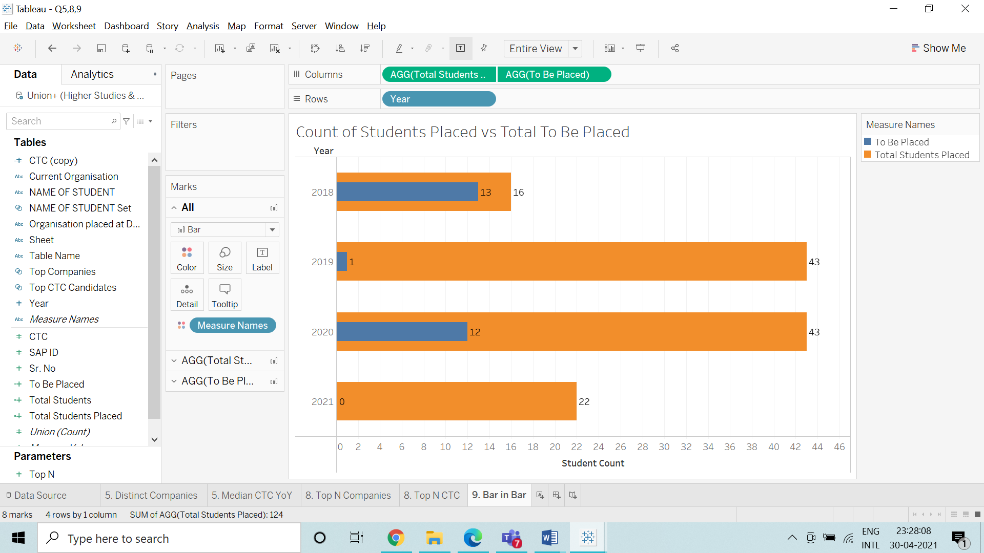

Total Students Placed and To Be Placed for each Year. Color shows details about Total Students Placed and To Be Placed. A Bar-in-Bar chart is obtained to justify the analysis.

**Insights Gathered:**

The students’ entry Merit Marks scoring format changing from a value out of 200 to a percentile range changed the ranking of students who got admitted to DJSCE. Thus, there was a significant change in the cut-off marks from year 2018 to year 2019. The CTC package offered to Electronics students has been gradually increasing each year.

The number of students opting for campus placements also has been gradually increasing from 2018 to 2020. The number of students opting for a Post-graduate degree has been gradually decreasing from 2018-2020. The reason behind this is stricter sanctions for visas and stricter policies in countries like the USA where the majority of students go for post-graduation.

Here, the median CTC package is the offer given by the mass-recruiter companies while the outlier CTC packages are the companies who picked up only a few students directly from the campus.

**Conclusion:**

This analysis was done mainly to pin-point the distribution of placement opportunities given to the students. It also picked up student trends for what they wished to do after graduating from DJSCE. This sort of information is important as then the program courses and co-curricular activities can be better designed by the faculty and the administration.

Students who opt for placements perform differently when compared to students who opt for higher studies. This is most evident in their results throughout the eight semesters and the scores for exams like AMCAT or GRE and GATE. Students tend to focus more on their area of interest and thus plan accordingly for their campus placements or admissions for post-graduation universities. An analysis based completely on students’ marks gives a different result than the one that’s based on only their DJSCE academic career or only the companies or universities they were picked up by or admitted too respectively.

Thus, this sort of analysis has created an entire student profile from the time they were admitted to DJSCE till the time they graduated successfully. This sort of historical data helped in referencing certain records even years later.